1. Pls read the tutorials carefully before flashing your PCB, the whole process will take about 10 mins.
2. Pls pay attention, when you get your new pcb, before soldering it, pls re-test all switches hole with tweezers(Pls open keyboard test software, if the key is active, the software key color will change). If one key is in-active, it may be Fn key or that key has in-active at this layout(such as ISO enter)

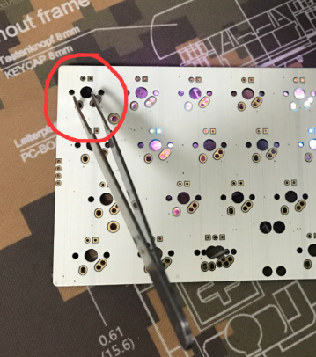

1. Before soldering, if the pcb meets any issue, we can help you solve it, after soldering, because we don’t know if the problem is caused by pcb itself, we can only accept repairing it(buyer need pay international shipping fee)

4、Before flashing it, pls make sure you have finished the next 3 steps**(Very Important)**:

**1\update your Chrome Browser to latest version(very i**

**2\Install TKG Chrome App**

**<https://chrome.google.com/webstore/detail/tkg-chrome-app/kmbmjdabhpdnpeobnbdchihdcdaccidi>**

**3\Install Zadig for Atmel DFU at your PC(you can check it at 001-Preparation Work)**